KRISHNA SCHOOL OF PHYSIOTHERAPY & REHABILITATION
Under Student Start-up & Innovation Policy 2.0, sensitization Phase was conducted for the students of Krishna School of Physiotherapy & Rehabilitation.
Date: 9 ^{th} June , 2025
Time: 10:30 am to 11:30 am
Mode: Offline
Venue: Smart Class
Participants: First and Second year Students of KSPR
Expert Speaker - Dr Amit Kumar Singh (PT)
Details:
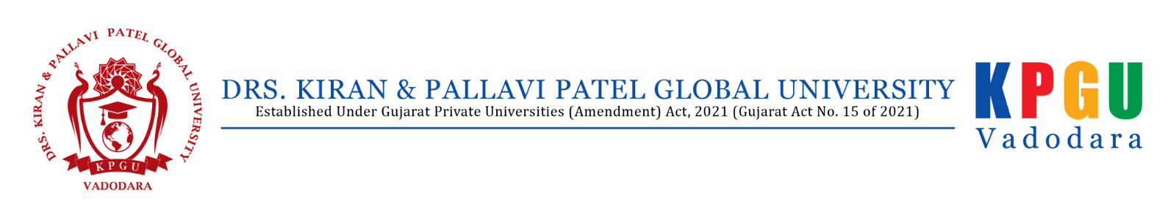
Krishna Centre of Startups & Entrepreneurship, Drs. Kiran & Pallavi Patel Global University (KPGU), Vadodara has organized SSIP Sensitization Program for the students of KSPR on Student Startup & Innovation Policy 2.0.
The following points were discussed about Student Startup & Innovation Policy 2.0.
⮚ Eligibility and Benefits were explained.
⮚ Support for Prototyping : SSIP has created mechanism through which students, innovators, start-ups can be given up to 2 lakh INR for developing prototype. Through State SSIP grant committee deserving teams can even fetch grant more than 2 lakh per project as per the need.
⮚ Support for IPR: Through SSIP, innovators can avail average 25 lakh INR grant for domestic IPR filing. SSIP also mandates student innovators for IPR protection beyond India and gives incentives for them .
Photographs
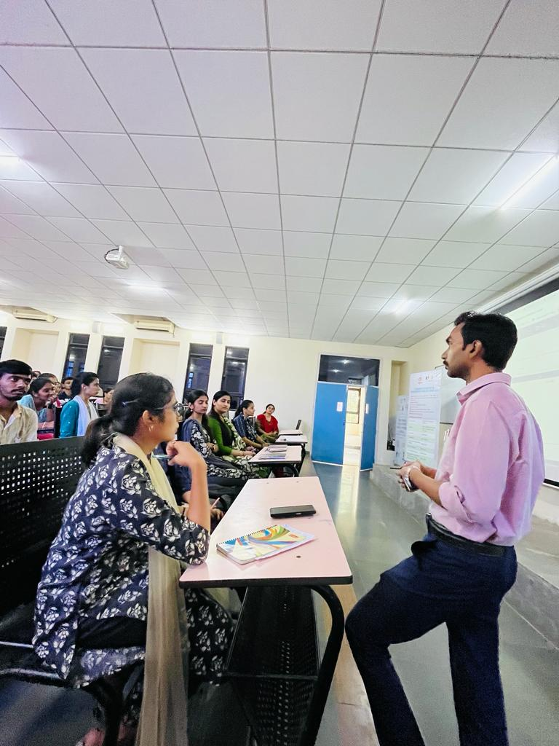
DR Amit Kumar Singh, PT
DR Harsha B Ramrakhiyani,PT
 | Dr. Paras Bhura
SSIP Coordinator | Director (I/c), KSPR

